**Previous Year Questions DSP**

1. Write a program for generating a composite signal (you could use sine or cosine waves). The parameters including the signal frequencies of 4 KHz, 8 KHz, 16 KHz with the amplitudes of 10 dB, 20 dB, 40 dB respectively, and the signal length should be limited to 1000 in samples.

a. Plot the generated signal.

b. Do standard sampling by following the Nyquist rate.

c. Perform under sampling and over sampling too. Use Subplot function to show the original, sampled, under sampled, and over sampled signal. Show the aliasing effect.

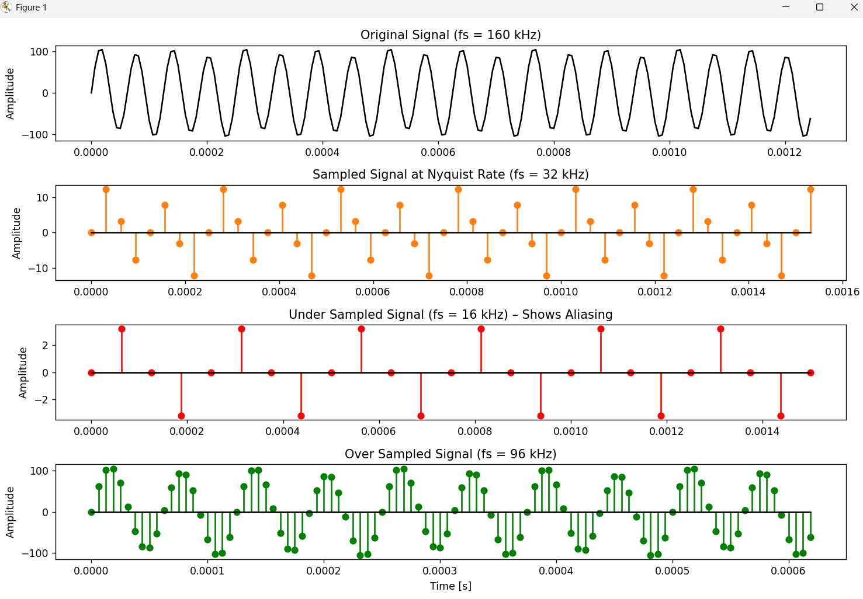

2. Consider a causal LTI system described by the difference equation y[n]= (3/4) y[n-1]-(1/8) y[n-2] +x[n]+ (1/3)x[n-1] ☆

(a) Find out System function H (z) for this system.

(b) Find out Impulse response sequence h[n] for this system

3. (a) Represent a continuous-time signal

(b) Sample the above signal and plot the Sampled Signal, and Obtain the Fourier transform of the discrete-time Signal and plot it, and observe the 'Aliasing' effect by sampling at different frequencies.

4 (a) Obtain linear convolution of sequence x[n]={1,1,1,1,1) and h[n]=(0,0,1,0,0). What is the observation? Show that convolution in TD is equivalent to multiplication in FD. Plot it.

Question(LAB TEST 2022)

1. Write a python program for generating a composite signal (you could use sine or cosine waves). The parameters including the signal frequencies of 40 Hz, 80 Hz, 160 Hz with the amplidute 10, 20, 40 respectively, and the signal length should be limited to 512 in samples.
2. Plot the generated signal
3. Do standard sampling by following the Nyquist rate.
4. Perform under sampling and over sampling too. Use subplot function to show the original, sampled, under sampled, and over sampled signal.
5. Then perform N=512 point DFT, show the magnitude and phase spectrum.